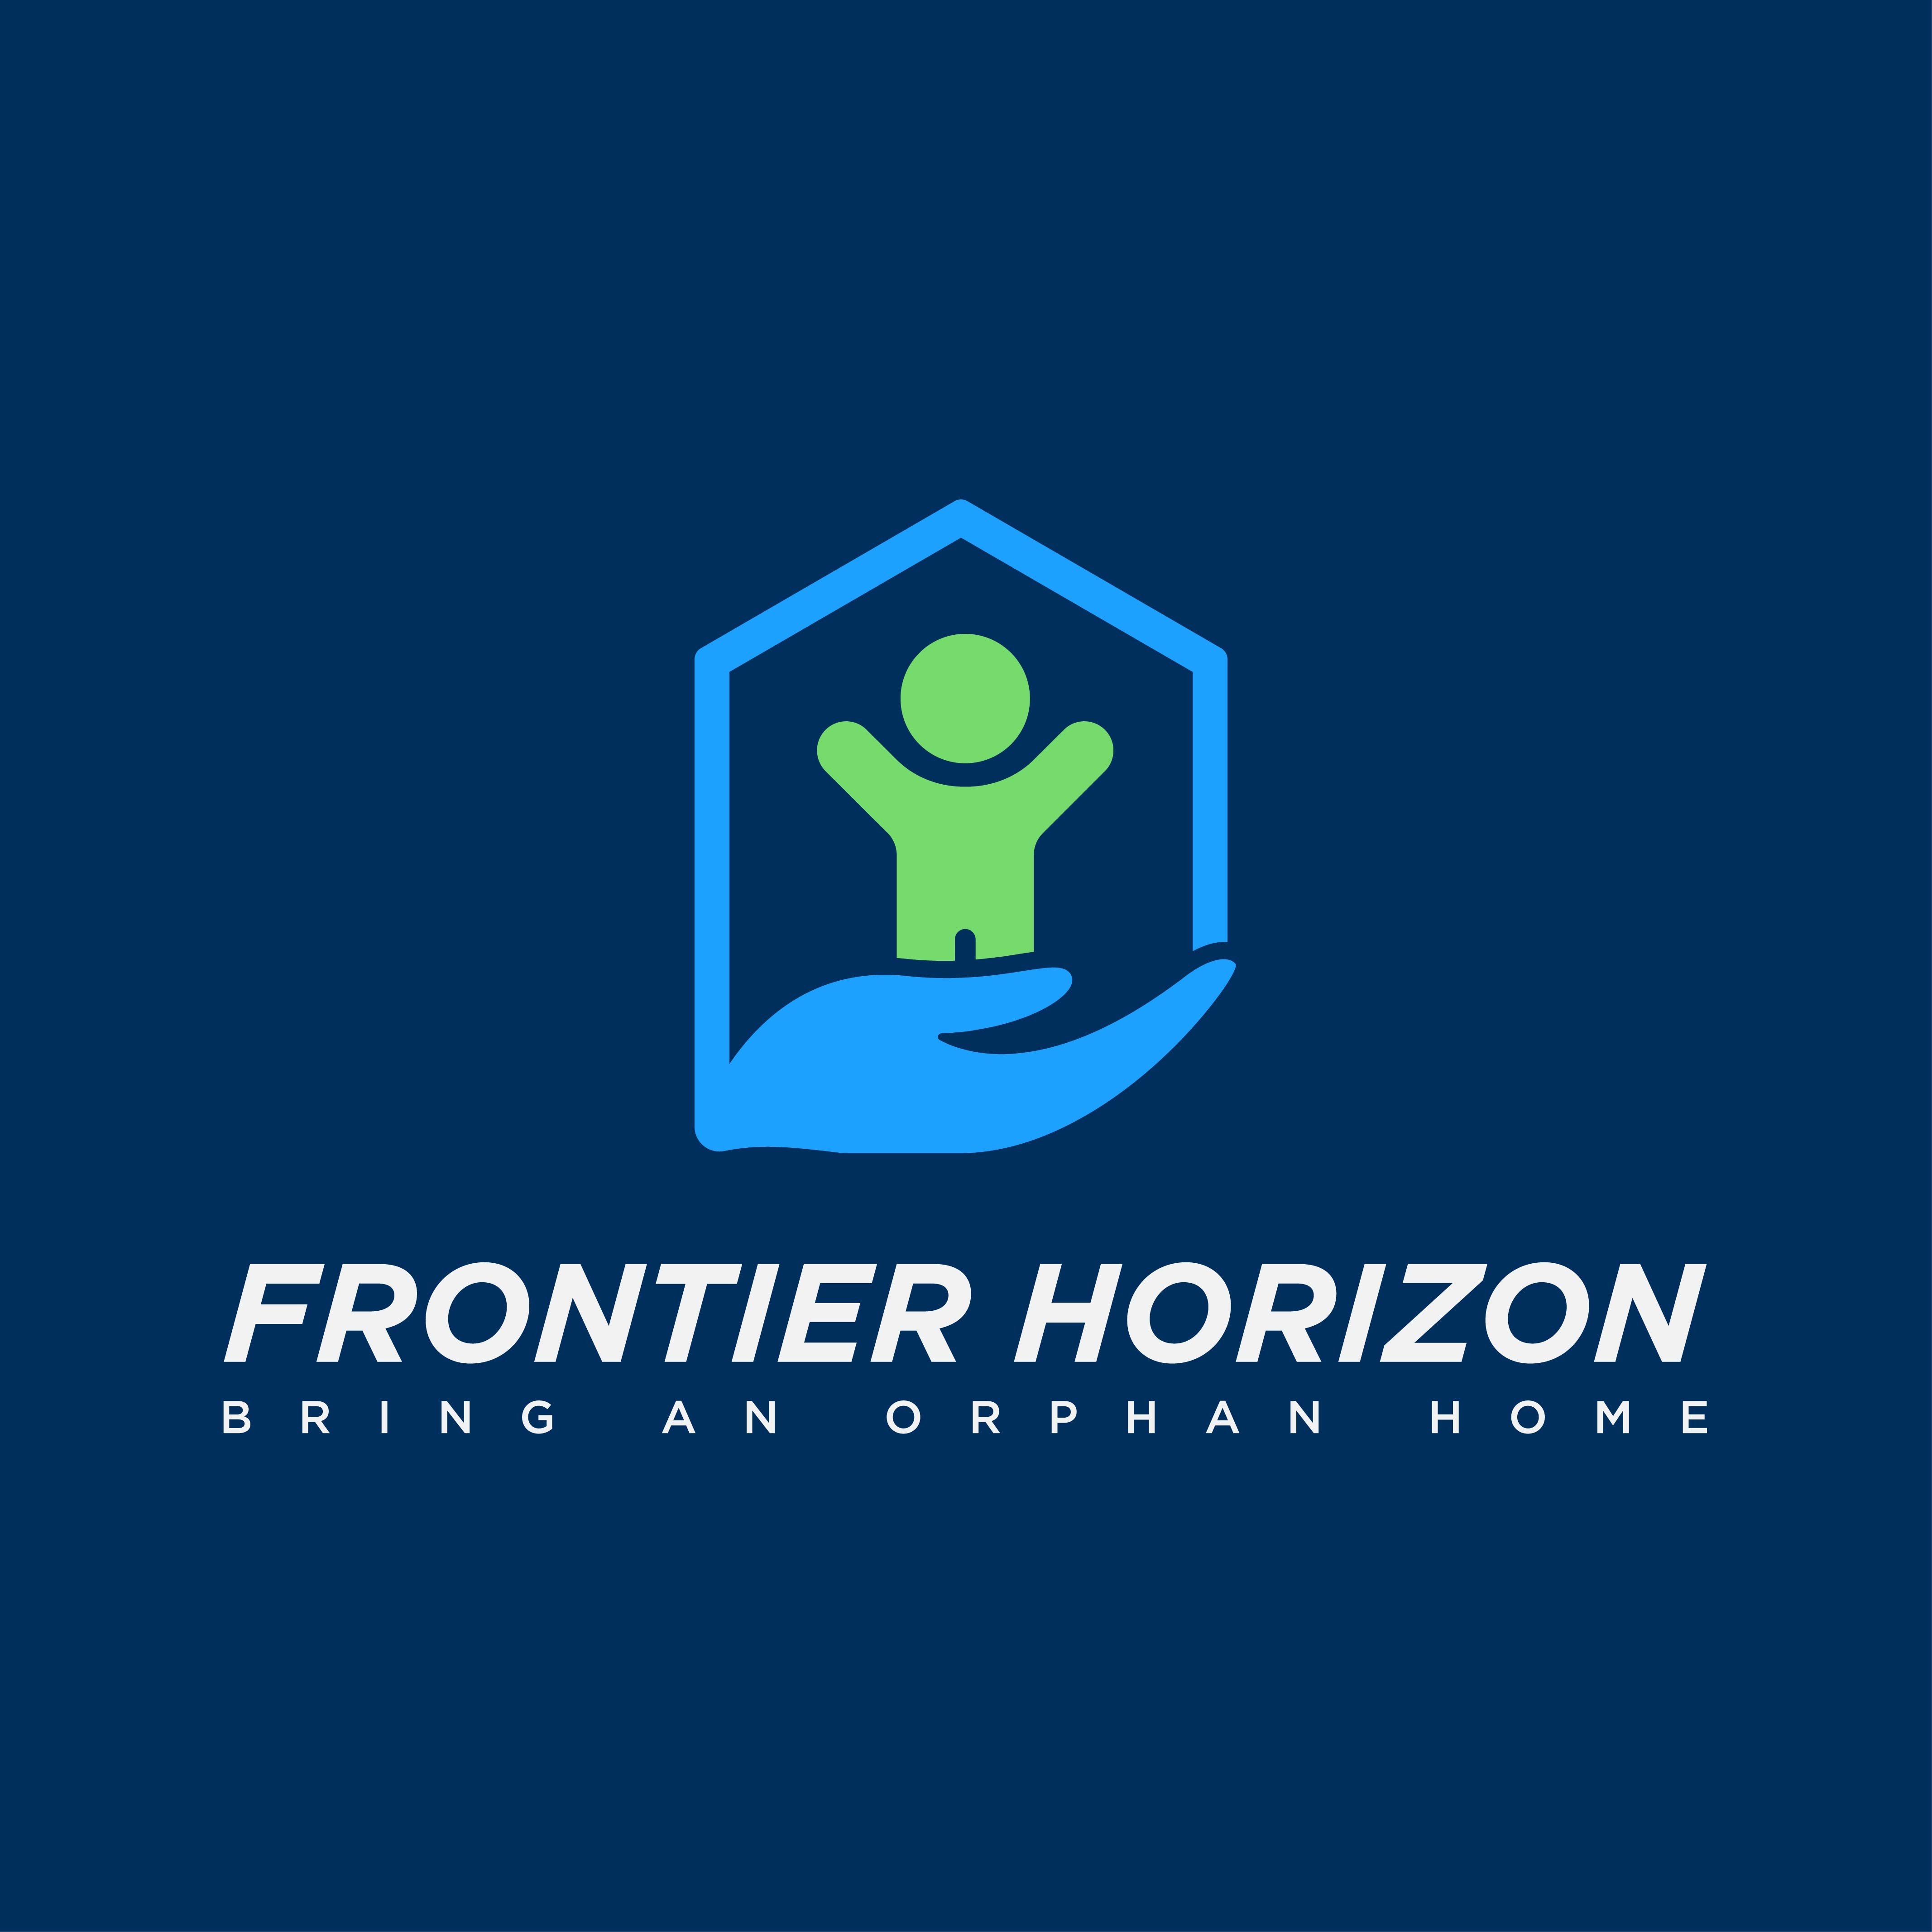 | Hosting Steps LIST

Done? | TASK | DISCRIPTION
☐ | Utilize Website Assets | Review website to learn from data provided on the site, especially the hosting FAQ page and hosting manual. These assets can be found via the “Resources” tab of the site.
☐ | Complete the Hosting Inquiry Form | This brief form, which can be found on the be found on the “Bulletin Board” of the Home pages of the Frontier Horizon website will begin the hosting engagement process. The slide on the Bulletin Board looks like a cell phone and reads, “Start your host journey today.” Completing this step will initiate a helpful email with robust information on the Frontier Horizon hosting program. If you do not see the email, please check your spam / junk folder.
☐ | Schedule an introductory call | The email referenced in the step above will include a link to schedule an introductory call. This call can also be secured by clicking the “Schedule a Call” button, which is on every page of the Frontier Horizon website. Once you have perused the Frontier Horizon website, and read the material included in the program overview email, your next action is to schedule a call to consider questions and details regarding next steps. This introductory call will provide you with an overview of Frontier Horizon and its programs. A team member will answer your initial questions and inform you of options with regard to moving forward in the process.
☐ | Review host child profiles to determine children of interest | Review all children highlighted in each of our programs. Utilize host child profile information and consider your family structure and dynamic to determine a good match.
☐ | Schedule a child discovery call | In this call the child’s full profile will be reviewed with you and further questions will be addressed regarding specific programs and children.
☐ | Complete hosting application | Complete digital application and submit it for review and approval. This digital document can be found on the Resources page of the Frontier Horizon website. (Applications will be reviewed once application fee is received.)
☐ | Pay application fee | Submit a $150 non-refundable application fee via the Frontier Horizon donation page. Designate given funds to “Pay your hosting fees” in the drop-down menu.
☐ | Place hosting deposit on child / children | Once your family feels confident in moving forward with a particular child / children you would then submit a $500 non-refundable deposit for each child you wish to secure for hosting. Designate given funds to “Pay your hosting fees” in the drop-down menu.
☐ | Complete a Short Home Study / Home Safety Visit | This qualifying home study is executed by your local child welfare agencies or related contractors. Please see the Home Study Requirement Guidelines document on Resources Pages of the Frontier Horizon website for basic requirements, and double check program-specific requirements with your hosting program manager.
☐ | Complete background check | A criminal background check is required for hosting. This action is most often included in the Short Home Study but can also be accessed via the following site for Nicaragua and Ukraine program: https://www.edo.cjis.gov/#/  NOTE: The Colombian program requires a different background check. Your program manager and/or Children’s House International, will guide you on this.
☐ | Prompt Return Agreement (PRA) | Every host family must read, sign, and return this document pertaining to the explicit agreement to return hosted children to the airport on the date of the program’s end.
☐ | Complete medical forms  (Ukraine only) | If you are part of the Ukraine program ONLY, all necessary medical forms must be completed and returned to Frontier Horizon.
☐ | Complete additional hosting paperwork (Colombia only) | If you are part of the Colombia program ONLY, Children’s House international will help guide you through some additional paperwork.
☐ | Pay Hosting Fees | In accordance with scheduled due dates, fulfill all hosting fee obligations. Designate given funds to “Pay your hosting fees” in the drop-down menu.
☐ | Purchase any additional airfare needed | Depending on your program, you may need to purchase additional airfare for you and/or your host child to get to your home from the hub airport. Your program manager will go over this with you.
☐ | Attend host family training | Attending host family online training is required of all host families and will be provided by Frontier Horizon.
☐ | Zoom call with your host kids (Colombia only) | Colombia program participants have a zoom call with their host children a few days to a week prior to the children’s arrival. Your program manager will schedule this with you.

